
Pentaho Data Integration
version 2.4.0

Integrating more, easier & faster!

Key differences with Kettle 2.3.0
List of changes on 20-01-'07

Compiled by Matt Casters, mcasters (at) pentaho.org
Send additional changes you found to this address.

Index
1. Changes summary 3
1.1. Preface 3
1.2. Overview 4
2. General changes 5
2.1. Spoon enhanced, RIP Chef 5
2.2. A new welcome screen 5
2.3. Variable support with visual feedback 5
2.4. A new execution configuration dialog 6
2.5. Slave servers & clustering 6
2.6. Databases 7
2.7. Shared objects 9
2.8. Repository improvements 10
3. Spoon 11
3.1. Extra options 11
3.2. Search meta-data 12
4. Steps 13
4.1. Text file input 13
4.2. Get System Info 13
4.3. Generate rows 14
4.4. Text file output 14
5. Source code improvements 15
5.1. A few extra lines of code 15
5.2. Trackers 15
5.3. Commiters 15
5.4. Other contributors 15

Changes summary

Preface
It's been almost 7 months since the last major revision of the Pentaho Data Integration software (a.k.a. Kettle). Again, we have had a lot of feedback, massive amounts of downloads and in general it's fair to say that the community is thriving on the new forum to which we migrated.

Overview
These are the most notable changes that have been made:
- Improved Performance and Scalability
- Remote monitoring and execution of Jobs and Transformations
- Clustering support (MPP)
- Database partitioning support (not to be confused with table partitioning)
- Numerous memory and performance improvements

- Enhanced database support
- Improved quoting algorithms
- separation of schema/owner and table names throughout the steps
- Databases connection pooling support
- Clustering support
- 25 database types (+generic) are now supported. The new database types that are supported now are: Teradata, Oracle RDB, H2, Netezza, IBM UniVerse and SQLite.

- Ease of Use
- Integrated Designer for Jobs and Transformations
- Design and edit multiple transformations simultaneously
- Repository improvements including the ability to sort contents by name, user, object type and modified date
- Variable enhancements including added support in many step types and visual indicators on all fields that support variables

- Powerful New Steps
- High performance, expression-based Javascript step
- Add XML step for building sophisticated XML constructs from stream fields
- Merge Join step for advanced joins like INNER, LEFT OUTER, RIGHT OUTER, AND FULL OUTER
- Fast Sorted Merge join for merging multiple streams sorted on the same key
- HTTP Client lookup to dynamically retrieve parameters using a web service

- Miscellaneous
- Remote monitoring of transformation and job execution
- Ability to share database connections using XML without having to use the repository
- Ability to roll-back entire transformations on error (unique connections)

- By the numbers
- >200.000 downloads of 2.3.0 and 2.3.1 (mostly 2.3.1)
- 4000 SVN commits
- >1000 forum threads
- 262 closed bugs with an average closing time of 29 days.
- 51 feature requests implemented with an average implementation time of 100 days.
- 10 developers committing to SVN

General changes

Spoon enhanced, RIP Chef
As you can see from the image below you can now load multiple transformations and jobs into a single Spoon editor. This removed the need for the Chef job editor and makes it easier to edit larger jobs.
Not only can you load jobs and transformations, but you can also run multiple jobs & transformations, monitor remote slave servers and view execution history in the same environment.
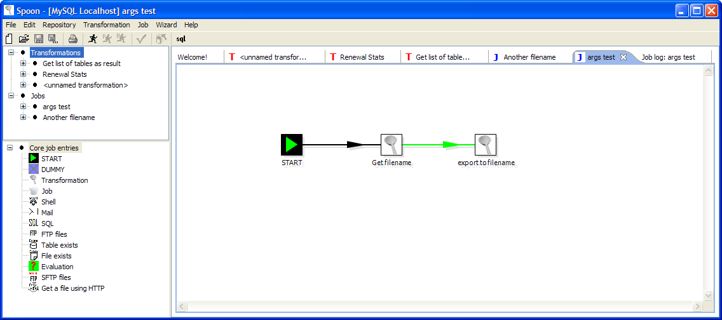

A new welcome screen
TODO: Make screenshot

Variable support with visual feedback

A new execution configuration dialog
This dialog combines local, remote and clustered execution as well as preview, log settings, safe mode, arguments and variable support in one dialog.
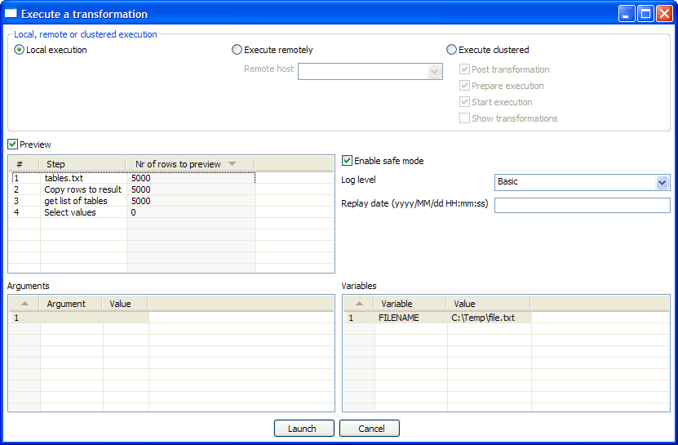

Slave servers & clustering
With this new release we move into the fascinating realm of massive parallel computing. It is now not only possible to execute a transformation on a remote server, but also to execute steps in a clustered way. By clustered we mean in parallel on more than one server. To allow this to work we created a small web-server called “Carte” that will accept input from either PDI Designer (remote & clustered execution) or from the Transformation job entry. (clustered execution)

Databases
- Teradata support (http://www.teradata.com/)
- Oracle RDB support (http://www.oracle.com)
- H2 support (http://www.h2database.com), requested first by Kent Andrews
- Netezza support (http://www.netezza.com), dialect and driver by Biswapesh Chattopadhyay for Google
- IBM UniVerse support (http://www-306.ibm.com/software/data/u2/universe/), testing & driver by Frans van Dortmont)
- SQLite support (http://www.sqlite.org/), implemented with help from Tom Gleeson http://gobansaor.wordpress.com/2006/12/18/sqlite-jdbc-and-kettle-pentaho-data-integration-etl/
- Connection pooling support added, written by 陈萍 (a.k.a. Apple : <chenping@gxlu.com.cn>), feature request 3838 by Jeremy Haile <javaforge@jhaile.fastmail.fm> was also implemented.
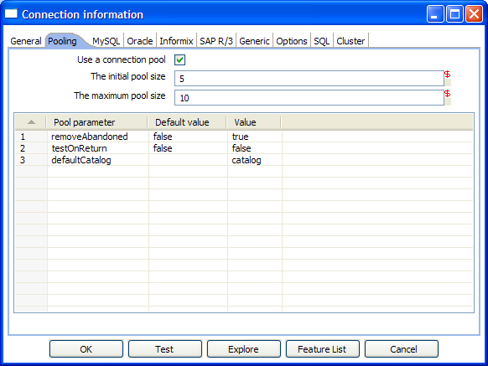
- Clustering/partitioning support to allow data to be split up among databases
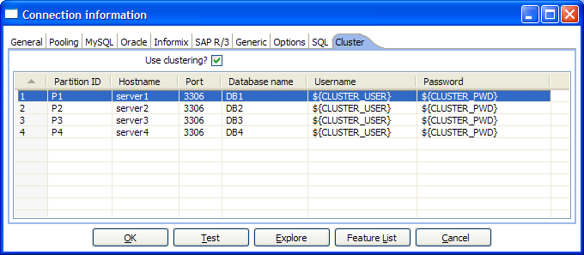
- MySQL: Allow cursor emulation (a.k.a. result streaming) to be turned off
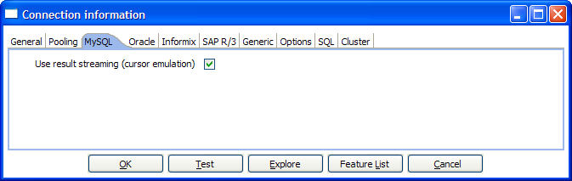
- Clicking the options help button now opens a new browser tab in Spoon:
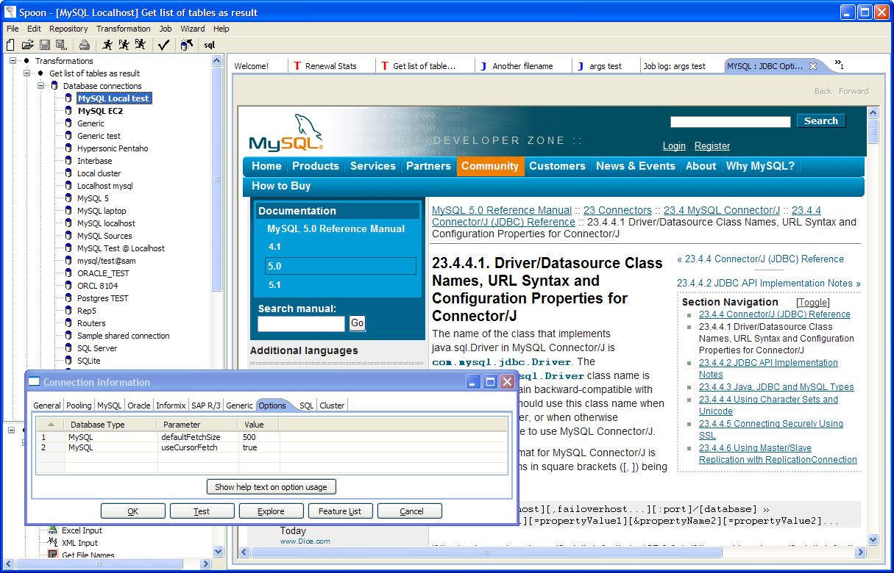
- Right after connecting, it is now possible to run a number of SQL commands. This is sometimes needed for various reasons such as licensing, configuration, logging, tracing, etc.
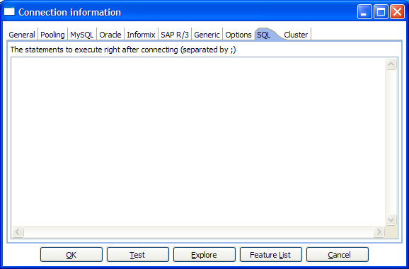
- JDNI connections are now also supported (code by James Dixon, Pentaho)

Shared objects
Various objects can now be placed in a shared objects file. This file (default: $HOME/.kettle/shared.xml) can be used to define:
- Database connections
- Steps
- Slave servers
- Partition schemas
- Cluster schemas

On these objects you can simply click right and select “Share”.

Doing so will place the object in the shared objects file. The location of the file is configurable:
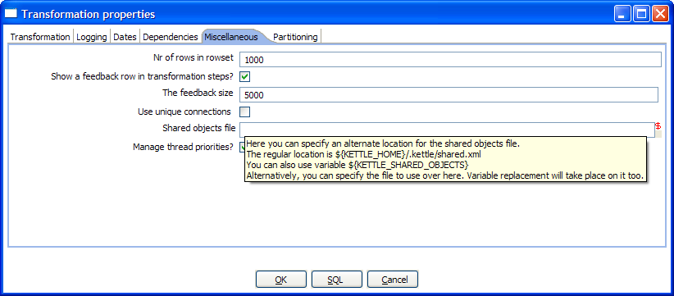

Repository improvements
We included extra information on the jobs and transformations stored in the repository in as well the repository explorer as the File/Open operations. This makes it easier for you to search for a particular transformation or job:
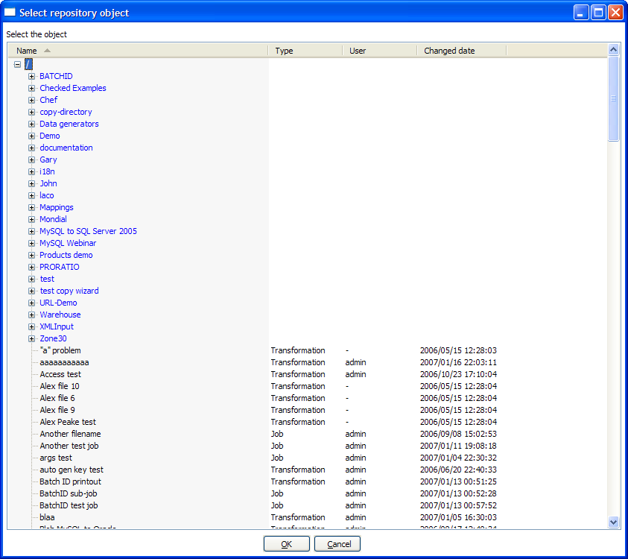
The repository also contains support for this as well as for the new objects like slave servers:
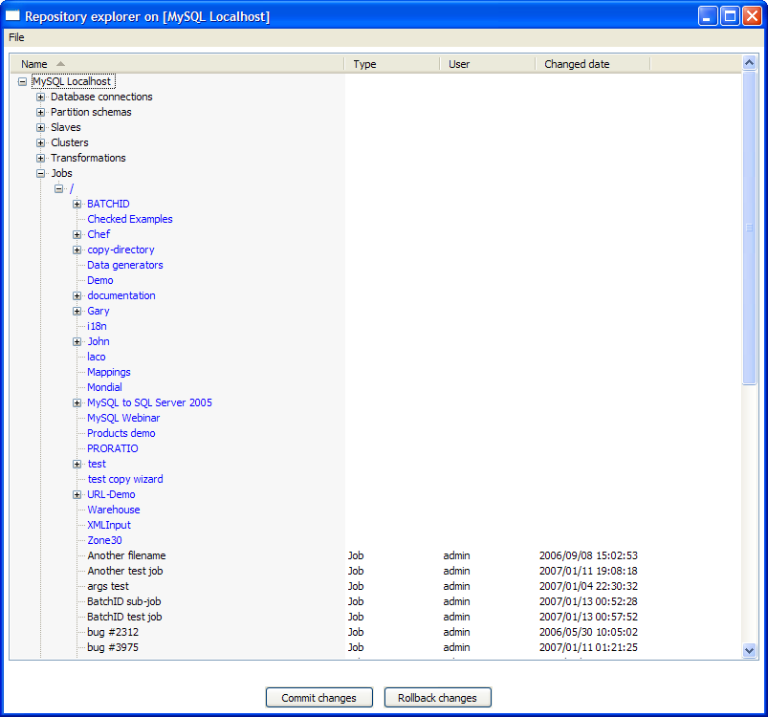

Spoon
For a list of the changes that were done in the steps & job entries, please see the corresponding chapters below.

Extra options
These are the new options that were added:
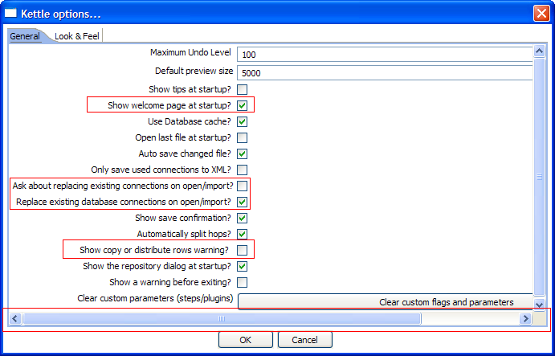
Most of the new options explain themselves. However, here are the details on the “copy/distribute rows warning” option. If you have a transformation like this:
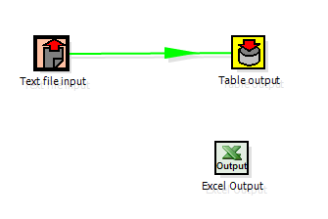
At the time you link step “Text file input” to “Excel Output”, you will be shown this dialog:
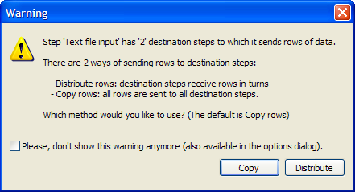
Apart from this, we made the dialog content scroll if it is shown too small. We do this to prevent option from being hidden involuntarily.

Search meta-data
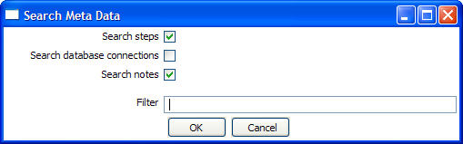
This option was introduced in 2.3.0 but will now search through all transformations and jobs that are loaded in Spoon.

Steps

Text file input
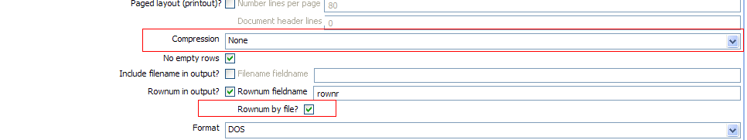
- Allow the method of compression to be specified as either Gzip or Zip.
- Allow the row number to be reset per file.

Get System Info
We gave access to the job start and end of the date range as well as the Kettle specifics like version, build date and build version.
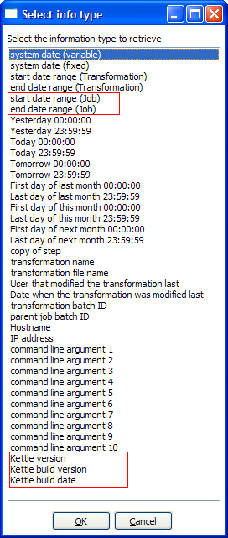

Generate rows
Now accepts for the limit to the number or generated rows a variable:
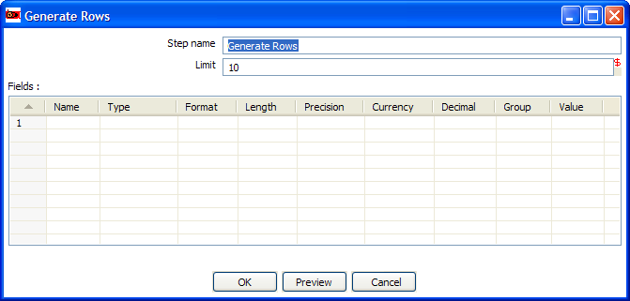

Text file output
We added support for Gzip and Zip compression as well as a “Fast data dump” option to speed up dumping large amounts of data to a text file. We also added the option to come up with an alternative ending for your text.
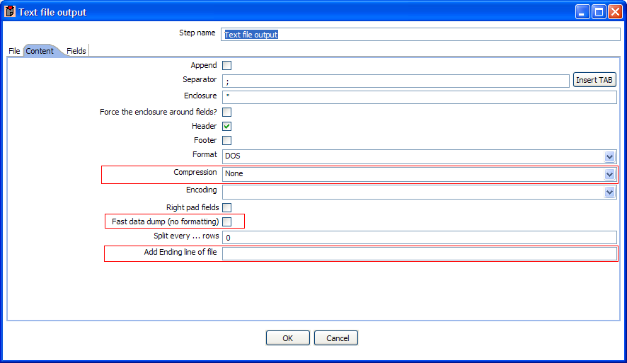

TODO: check other steps & job entries

Source code improvements

A few extra lines of code
Version 2.1.4 contains 160,000 lines of code.
Version 2.2.2 contains 177,450 lines of code, an increase of 17,450 lines.
Version 2.3.0 contains 213,489 lines of code, an increase of 36,039 lines.
Version 2.4.0 contains 256,030 lines of code, an increase of 42,541 lines.

Trackers
In the period between the release of version 2.3.0 on june 27th 2006 until January 25th, 2006 we fixed 262 bugs and 51 feature requests where implemented.

Committers
ID / Commits | e-Mail | Name | Country | Work
TOTAL  4,000 | 10 developers |  | 6 countries

Other contributors
Disclaimer: The list below is by no means complete. Many people files bug fixes and feature requests anonymously. Others were probably shamelessly bypassed. Please remember that this is not done on purpose but rather a result of the limited time we can spend on these type of documents. If you were one of the victims of this horrible policy, simply contact the maintainer of this document and you will be added immediately. The same is true for everyone that DOESN'T want to be on this list: just let us know.

- The entire crew at Pentaho for the many suggestions for improvements, bug reports and continued support.
- Etienne Dubé (etdube)
  - Fixed a complex rounding problem for numbers with double data type. Proposed the java code fix to solve it as well. (Tracker #1876)
  - Found out that the Select Values doesn’t save the type correctly to XML (must have been in there forever) and proposed the fix as well. (Tracker #1875)
  - Proposed a fix for a problem with the Mapping step. (Tracker #1874)
- Christopher Fahey (chrostpher.fahey (at) comcast.net)
  - Proposed code to enhance Text File Input: look at the header to determine the order in which fields occur in the text file
  - Bug fix in Normaliser step: first=false flag was forgotten
- lokvin (Ren Yufei, purcr (at) hotmail.com)
  - Created a flash demo in Chinese
- Kettle partner Ixor, Johnny Vanhentenryk [jvanhent (at) gmail.com], Dennis Vanroeyen [dennis.vanroeyen (at) gmail.com]
  - Changes paid for by Mondial Assistance Group released into the Kettle code base for a project in Japan, I’m verifying the changes.
  - Most of the text file input and excel input error handling
  - various bug fixes
  - Replay functionality
  - JUnit tests and use case library for text file input and excel input steps with test files and transformations.

- Bernardo Arlandis Mañó [bernardo (at) tsolucio.com]
  - Proposes to help with localization
  - Wants to hire a professional company to do the Kettle translation to Spanish
  - I gave him an account and I’m helping him find his way around in the codebase.
  - Also wants to help with migration of localization from 3.0.1 to the trunk
- Pentaho partner Proratio: Jens Bleuel [jens.bleuel (at) proratio.de]
  - Registration of Kettle presentation for Linuxtag
  - Question answering on forum
  - Bug reporting
- Steven Lehr [lehrs (at) erau.edu]
  - Wrote most of next weeks Kettle tip: several gotcha’s for first time users
- Ben Stroud [ben.stroud (at) waypointdatasolutions.com]
  - Fixing TextFileInputDialog GUI bug on GTK (Linux)
- Craig Moran [cmohan (at) shoppertrak.com]
  - Bug reporting and testing on the OSX platform (Spoon and particularly Chef)
- Catalin Pitis [cpitis (at) gmail.com]
  - Various feedbacks on the forum, suggestions and bug reports
- David Hurst [dthurst (at) cogniscape.com]
  - XSL Transform Suggestion
- Frank Schunig [Frank.Schunig (at) shd-online.de]
  - Bug reporting on exceptions in Spoon
- Gergő Bácskai [gbacskai (at) gmail.com]
  - Big help entering bug reports, feature reports and doing suggestions!
- Giyora Megido [giyoramegido (at) gmail.com]
  - Various bug reports and questions on the forum.
- Gunter Rombauts [gunter_rombauts (at) chicago-metallic.be]
  - Suggestions and bug reporting
- Nicholas Guzaldo [guzaldon (at) gmail.com]
  - Big help in all areas: feedback, bug reporting, forum, ...
- Hans Baier [hans.baier (at) soluzione.de]
  - Bug reporting on Copy Tables Wizard & Hypersonic
- Gavin Higgo [Gavin.Higgo (at) auspost.com.au]
  - Reporting DBCache bug & testing solution
- Andrew Hoesley [hoezx6r (at) gmail.com]
  - Various suggestions and bug reports
- Jaime Madrid [jaime.madrid (at) gmail.com]
  - Problem reporting and testing
- James Bradt [javaforge.x.bradtwurst (at) xoxy.net]
  - Reporting on MS-Access alter table problem & solution
- Jens Bleuel [jbleuel (at) proratio.de]
  - Bug reporting, testing, fixing, documenting, forum participation, ..., being a nice guy.
- Jesper Villadsen [JSV (at) maconomy.dk] (and colleages :-))
  - Various suggestions, feedback and bug reports
- Jules Grengbondai [jgrengbondai (at) cincom.com]
  - Forum questions, suggestions, feedback
- Jocelyn Bernier [jbernier (at) dalcom-intl.com]
  - Enter options dialog bug report
- Jonathon Coombes [jon (at) cybersite.com.au]
  - Lots of feedback and bug reports on OSX, MySQL (5.1.x), Linux 64bit, etc.
  - Forum support, questions and feedback
- Mark Nuttall [mknuttall (at) gmail.com]
  - Suggestions on OpenAdapter stuff that we should probably pick up in the near future.
- Mark Tetrode [mark.tetrode (at) altitude.com]
  - Suggestions on GUI looks, sample dialogs, etc.
- Mason Sharp [msharp (at) extendb.com]
  - Added ExtenDB support (patch) as well as the JDBC driver for this database.
  - Suggestions on batch processing in the Insert/Update step.
- Matthew Walnock [matthew.walnock (at) gmail.com]
  - Suggestion (feature request) on extending user rights to repository directories.
- Matt Harbert [mharbert (at) divx.com]
  - Feature request for Mail job entry with secure authentication support.
- Youssef Mbaret [mrabetyoussef (at) gmail.com]
  - Big help on the forum
  - Plenty of feedback and bug reports
  - Wrote new “XML parsing by Value” plug-in that makes reading XML docs a lot faster.
  - Performance testing on PostgreSQL
- Olivier Clemens [olivier.clemens (at) mondial-assistance-group.com] and colleages at Mondial
  - Feature requests, bug reports & much appreciated continued support!
- Paul Lewen [Plewin (at) s-und-n.de] and colleages at S+D
  - Helping detect and solve a serious performance problem
- Raoni Guerra [raoniguerra (at) hotmail.com]
  - Bug reporting on PostgreSQL
- Rich Cristy [rchristy (at) skyroadasp.com]
  - Feedback on Text File Input, compilation issues, testing and bug reporting on the forum.
- Roland Bouman [[roland.bouman (at) gmail.com]
  - Dutch translator for Kettle
  - Documentation updates & reviewing
  - Doing a very nice blog on Kettle & Pentaho:
    - http://rpbouman.blogspot.com/2006/06/pentaho-data-integration-kettle-turns.html
  - Helping out on the forum, suggestions, bug reports, etc.
- Hassan Samatar [sahass78 (at) yahoo.fr]
  - French translator for Kettle
  - Huge help on the forum
  - Bug reporting, feature requests, etc.
- Sergio Ayuso Iniesta [sayuso (at) satec.es]
  - Bug reporting on the Combination Lookup step

- Seth Ladd [seth (at) ehawaii.gov]
  - Feature request on hard returns in enclosed Text Files fields.
  - Javascript step feedback on the forum
- Shuo Wang [shuo_wang_2000 (at) yahoo.com]
  - Various feedback on the forum, bug reports and testing
- Sven Boden [Sven.Boden (at) pandora.be]
  - Wrote unit test cases
  - Did java code reviews
  - bug reporting & fixing
  - Wrote a lots of improvements to the code.
  - Documentation review & updates
  - Big help on the forum answering questions
  - Java advice & test code
- Marc D Swingler [Swingler.MarcD (at) ensco.com]
  - Bug & feature report on data type handling on SQL Server
  - MySQL testing, Feature request for identity fields, ...
- Tom Qin [qinhui99 (at) hotmail.com]
  - Simplified Chinese translator for Kettle
  - Big help on the project, the forum, ...
- Zachary Zeus [zachary (at) polonious.com.au]
  - Helping out on OSX and reporting on the Sorting a column Kettle crash on that platform.
- Lee Bruise [workformydream (at) yahoo.com]
  - Found a problem in Table Input step with variable replacement and suggested the fix for it.

